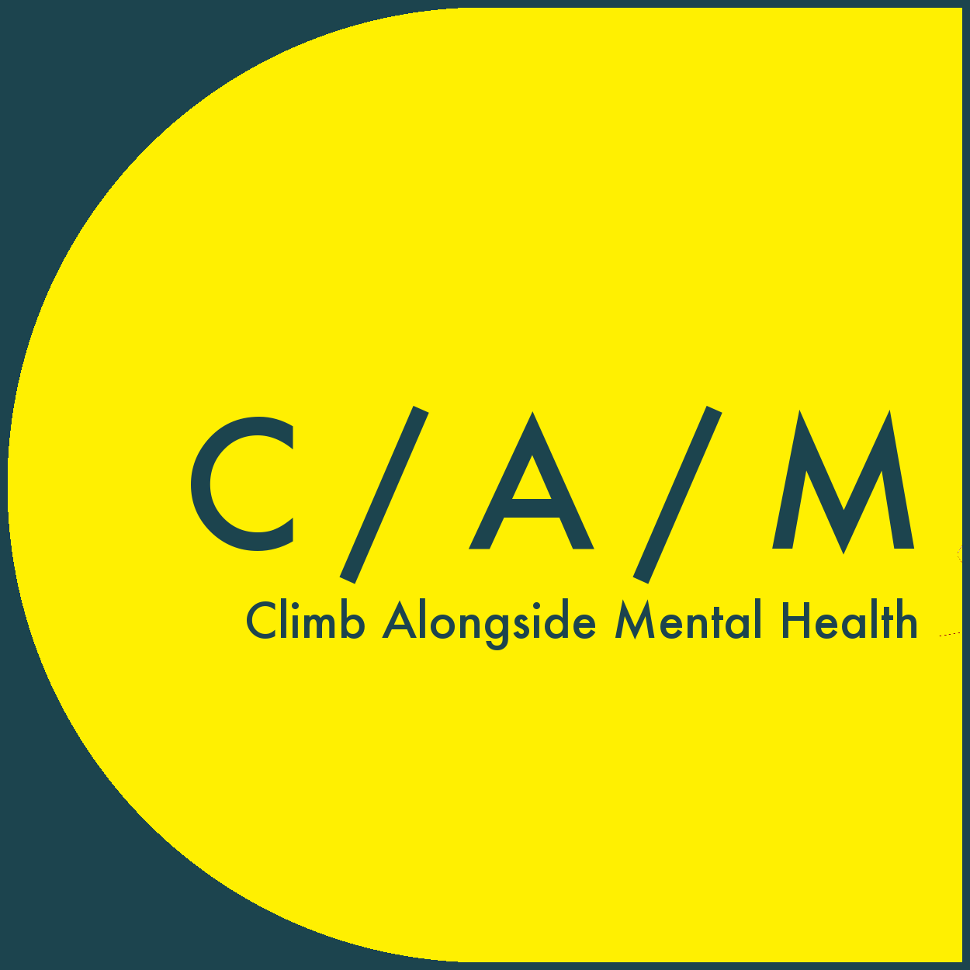C / A / M  
Climb Alongside Mental Health

www.climbalongsidementalhealth.org

info@climbalongsidementalhealth.org

The C/A/M Climbing Initiative

Referral Form: Multiple Sessions @ The Climbing Lab

This form is for redeeming a 5 climb gift card for the Climbing Lab, Leeds.

It has sections for completing by both the referrer and referee.   
  
Five climb gift card: allows for 5 free entries into the Climbing Lab. These are not instructor-led sessions, so you can go any time you want to during opening hours, without booking in advance.   
  
Please note this does not include shoe or chalk hire.

This is suitable for individuals who do not need supervising/instruction (i.e. have climbed before). If this will be the first time trying climbing, please complete the ‘Climbing Initiative’ referral form (<https://www.climbalongsidementalhealth.org/referral-form>) and send that directly to the Climbing Lab to book a free one-off instruction session. Once you have completed this, then you can use your gift cards for unsupervised sessions.

Once completed all sections on the next page, please email this form to [info@climbalongsidementalhealth.org](mailto:info@climbalongsidementalhealth.org)

Someone from C/A/M will be in touch with the referee directly to confirm the booking. Please keep an eye out for emails going into your junk folder.

More information about C/A/M can be found at: [www.climbalongsidementalhealth.org](http://www.climbalongsidementalhealth.org)

C / A / M  
Climb Alongside Mental Health

www.climbalongsidementalhealth.org

info@climbalongsidementalhealth.org

Referee/Service User Details

By giving my details below, I agree to them being given to C/A/M representatives, for the purpose of communication about the multiple climbing sessions at The Climbing Lab.

Full name:

Email address:

Phone number:

*Contact details are required to send the gift card and will be shared with the Climbing Lab when booking. They will not be passed on to any other parties without your expressed permission.*

Healthcare Professional Declaration

I declare that _________________________ is eligible for ‘The C/A/M Climbing Initiative’.

Job Title:

Place of Work:

Contact details:  
Signed:  
Name:  
Date: